Database Systems Lab (CL-2005)
Hackathon
Total Time: 1Hr
Total Weightage: 5
Total Marks: 16
Total Questions: 08
Paper B

Date: Wed, April 29th, 2026
Time: 2:30 PM to 03:30 PM
Lab Instructor(s):
Saira Ayub.

____________________________ ____________________ _____________ ________________________
Student Name Roll No Section Student Signature

Do not write below this line
Attempt all the questions!
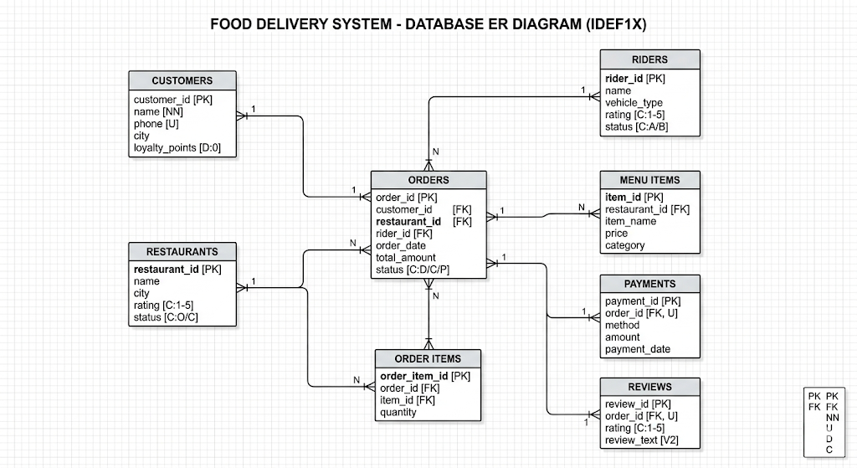

Tasks:
- A logistics company is planning a promotional discount for customers living in Lahore. Write a query to display the name and phone number of all customers who live in Lahore.
- The operations team wants a combined report showing which customer placed which order and which rider delivered it, along with the total amount of each order. Write a query to display customer name, rider name, and total order amount.
- The system administrator decides that every rider must have an email address, and no two riders can share the same email. Write an SQL statement to add an email column to the Riders table.
- The system wants to generate a cleaner report of delivery riders for analysis purposes. Write an SQL query to display the following information from the Riders table the vehicle type in uppercase format and only the last 3 characters of each rider’s name
- The finance department wants to identify which restaurant locations generate higher revenue.Write a query to calculate the total order amount for each restaurant’s city, and display only those cities where the total revenue is greater than 1000.
- The marketing team wants to identify premium customers. Write a query to find the names of customers whose total order amount is greater than the average order amount of all orders in the system.
- The operations team needs a consolidated report for daily monitoring. Create a view that displays the following information: rider name, order ID, order total amount, order status
- The company wants to track every change in a rider’s availability status. First, create a history table to store rider status changes. Then create a trigger that automatically inserts a record into this table whenever a rider’s status is updated.

